Building the MOI FIT Environment

1 Document Revision History 2
2 Workspace Default Settings 3
3 Building DbFit from the Source Code Distribution 4
3.1 Building DbFit/Java 1.1 (Base Version) 4
3.2 Building DbFit/.Net 1.1 (Base Version) 4
4 Building DbFit from the MOI TFS Project 6
4.1 Building DbFit/Java 1.1 (Base Version) 6
4.2 Building DbFit/.Net 1.1 (Base Version) 6
5 Building Fitnesse20080812 from the Source Code Distribution 7
6 Building Fitlibrary20070225 from the Source Code Distribution 8
7 Debugging FitNesse Fixtures with Eclipse 9

Document Revision History
Version Date | Version Author | Version Description
23rd May 2012 | Mark Matten | Created to document DbFit build instructions.
19th September 2012 | Mark Matten | Updated with FitNesse and FitLibrary build instructions.

Workspace Default Settings
Use a version 1.5 JDK to build the following binary distributions. Alternatively use a project specific setting for each project and set the project to use a 1.5 JDK compiler. This can also be specified by setting the JRE library version used on the projects’ build path.

Building DbFit from the Source Code Distribution

Building DbFit/Java 1.1 (Base Version)

- Install Eclipse for Java Developers (e.g. the ‘Europa’ or ‘Helios’ version) from “\\stafs04\OnePlanDev2\MOI\Software\Eclipse”.
- Start the Eclipse IDE.
- Create a new workspace if required (e.g. by entering “C:\MOI\EclipseWorkspaces\Workspace1”) else open an existing workspace.
- File -> Import.
- Select “General/Existing Projects into Workspace”.
- Navigate to “C:\MOI\Configuration\Tools\Source Code\DbFit1.1.x\impl\java”. You should see “dbfit4j” listed in the projects list. Click “Finish”.

The project should automatically be built (as long as “Build Automatically” is selected on the Project menu, if not build it with Project -> Build Project). You’ll probably see 20 or so warning messages about the use of generic types. These warnings are not significant to the operation of DbFit.

Finally, create a Java ARchive (JAR) file of the compiled class files for use with FitNesse: -
- Right click on the “dbfit4j” project->Export…->Java->JAR file then click “Next”.
- Make sure the “dbfit4j” project is selected.
- Select the target file path and name. E.g. “C:\MOI\Configuration\Tools\FitNesse\dbfit-complete-20080822_DEV1\lib\dbfit.jar”.

Building DbFit/.Net 1.1 (Base Version)

- Start a virtual CD/DVD drive manager (such as Daemon Tools Lite - \\stafs04\OnePlanDev2\MOI\Software\Daemon Tools\DTLite4451-0236.exe).
- Install Microsoft Visual C# 2005 Express from \\stafs04\OnePlanDev2\MOI\Software\Microsoft Visual Studio\2005 after first mounting the ISO image file using Daemon Tools.
- Install the DB2 .Net provider from “\\stafs04\OnePlanDev2\MOI\Software\Microsoft .Net Data Providers\IBM DB2”.
- Start the Visual C# Express IDE.
- Open the solution by navigating to the solution file “DbFit.sln” and opening it in Visual Studio (File->Open).
- From the menus click Build->Build Solution. Visual Studio will build the project and place an updated “dbfit.dll” file into the “impl\dotnet\bin\Debug” directory. E.g. into “C:\MOI\Configuration\Tools\Source Code\DbFit1.1.x\impl\dotnet\bin\Debug”. This file can then be copied to the appropriate directory to be tested/released/etc.

Building DbFit from the MOI TFS Project

Building DbFit/Java 1.1 (Base Version)
- Install the required software as in this section.
- Update your ‘Configuration’ workspace folder from TFS.
- Create a new Java project (File->New->Java Project). Enter the project name “dbfit4j” and click “Next”.
- We now need to link in the existing source code folders that have been downloaded from TFS.
  - On the “Source” tab of the dialogue click “Link Additional Source” and navigate to “C:\MOI\Configuration\Tools\Source Code\DbFit1.1.x\impl\java\src”.
  - On the “Source” tab of the dialogue click “Link Additional Source” and navigate to “C:\MOI\Configuration\Tools\Source Code\DbFit1.1.x\impl\java\test”.
  - You’ll now see the sources listed in their packages in the Package Explorer view.
- Now include the dependencies (libraries) in the project by right-clicking on the project->Properties->Java Build Path->Libraries (tab)->Add External JARs.
- Navigate to “C:\MOI\Configuration\Tools\Source Code\DbFit1.1.x\impl\java\lib” and add the following JARs: -
  - fitlibrary.jar
  - fitnesse.jar
  - ojdbc14.jar
  - derbyclient.jar
  - mysql-connector-java-5.0.7-bin.jar
- All icons in the project in the Package Explorer should no longer have the red “x” overlay and the project should now be built.
- Export the JAR file as in this section.

Building DbFit/.Net 1.1 (Base Version)
- Install the required software as in this section.
- Update your ‘Configuration’ workspace folder from TFS.
- We now need to link in the existing source code folders that have been downloaded from TFS. On the “Source” tab of the dialogue click “Link Additional Source” and navigate to “C:\MOI\Configuration\Tools\Source Code\DbFit1.1.x\impl\java\src”. You’ll now see the sources listed in their packages in the Package Explorer view.
- Start Visual C# Express 2005 and open the DbFit solution (File->Open) by navigating to “C:\MOI\Configuration\Tools\Source Code\DbFit1.1.x\impl\dotnet” and opening the solution “DbFit.sln”.
- Build the solution as in this section.

Building Fitnesse20080812 from the Source Code Distribution
- From the menus, select: -
  - File -> New -> Other… -> Java / Java Project from Existing Ant Buildfile
- Navigate to the build file. E.g. to: -
  - C:\MOI\Configuration\Tools\Source Code\fitnesse_src20080812
- Select any of the entries in the list of “javac” declarations found in the file and click Finish.
- Check the project (right-click on the project -> Properties -> Java Compiler) and alternative Java compiler properties if required. E.g. to use JDK 1.5 instead of 1.6.
- To export the compiled code, as a JAR file, right-click on the project -> Export…
- Export the JAR file, as in this section, with an output file name of “fitnesse20080812.jar”.

NOTE: a binary (JAR file) dependency of this build is Fitlibrary version 20070225. It is included in the “lib” directory imported into the project.

Building Fitlibrary20070225 from the Source Code Distribution
- Extract the contents of the following archive file to a temporary empty directory: -
  - \\stafs04\OnePlanDev2\MOI\Software\Fit-FitNesse-FitLibrary-FitSharp\Fitlibrary-FitlibraryWeb\FitLibrary20070225.zip
- From the menus, select: -
  - File -> New -> Java Project…
  - Name the project “FitLibrary20070225”.
- Right-click on the project -> New -> Source Folder. Name the folder “src”.
- Right-click on the “src” folder -> Import -> General/Archive File -> Next.
- Navigate to the location that the archive file was unpacked to and select the source code JAR archive file “FitLibrarySrc.jar”.
- Right-click on the project -> Import -> General/File System -> Next.
- Navigate to the location that the archive file was unpacked to and select the directory “lib”. Make sure that “Create Selected folders only” is selected and NOT “Create complete folder structure”.
- Right-click on the project -> Import -> General/File System -> Next.
- Right-click on the “lib” folder -> Import -> General/File System -> Next.
- Navigate to the following direcotry: -
  - \\stafs04\OnePlanDev2\MOI\Software\Fit-FitNesse-FitLibrary-FitSharp\FitNesse\FitNesseRelease20060719
- Select the file “fitnesse.jar”.
- Right-click on the project -> Properties -> Java Build Path.
- Select the Libraries tab then click “Add JARs”.
- Expand the “FitLibrary20070225” project and the “lib” folder inside it.
- Select the three JAR files (shift + click) and click “OK”, then “OK” again.
- The project will then be built correctly apart from the class “DefineTemplateTraverse” in the package “fitlibrary.traverse.workflow”. In order to make this class build correctly modify the line: -
  - return ((String)arg1).compareTo(arg0);
  - to be
  - return ((String)arg1).compareTo((String) arg0);
- Export the JAR file, as in this section, with an output file name of “fitlibary20070225.jar”.

Debugging FitNesse Fixtures with Eclipse
The following information is from the following web site posting: -

http://vikashazrati.wordpress.com/2007/12/05/remote-debugging-fitnesse-with-eclipse/

We use Fitnesse as the acceptance testing tool for our projects. Many a times it becomes a necessity to remotely debug how the fitnesse fixture is running through your code.
This blog would try to explain how you can easily set up a remote debugging session between Fitnesse and Eclipse so that you can debug through the code as your fixture is being executed.
In your Eclipse IDE
1. Goto Run->Open Debug Dialog
2. Right click on Remote Java Application option in the left hand menu tree and say new
3. Create a remote java application debug configuration like this
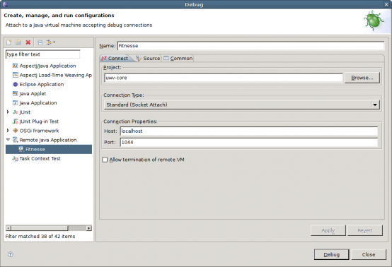
4. Add the sources to the configuration. These should be all your java projects.These are required so that while remotely debugging you can walk through your code
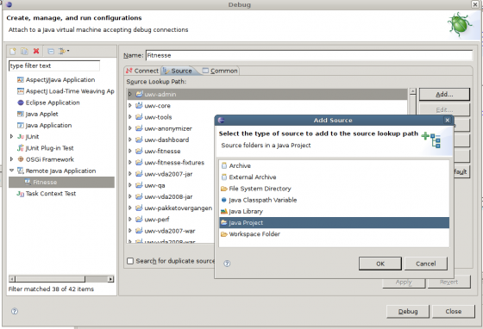
5. Now your Eclipse configuration is done. Note that we have told eclipse to listen at port 1044 and have specified all the source files that it should use for code walkthrough.
6. If you hit the debug button at this moment you would get an error. Why? because right now fitnesse is not executing and eclipse would not find anything to listen to at port 1044. Hence you would see something like this
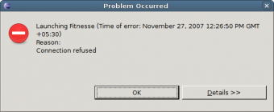
7. Now add the following line to the fixture that you want to debug
!define COMMAND_PATTERN {java -Xdebug -Xrunjdwp:transport=dt_socket,server=y,suspend=y,address=1044 -cp %p %m}
5. Start the test in fitnesse
6. Goto Eclipse, open Debug dialog, select the Remote java application that we just created and hit debug button.
7. The debug view would now open at the first breakpoint
Happy Debugging!

